## CHAPTER 2

**System Analysis**

## 2.1. Determining System Requirements

### 2.1.1. Detail overview of the existing system

2.1.2. Problems encountered by the existing system.

Identifying the shortcomings of the current system is a critical step in addressing and improving the agricultural product exporting process. Various methodologies have been employed to gain insight into the existing system, including interviews with key stakeholders (Farmers, Exporters and Government bodies), distributing google forms to students with agricultural background and thorough document reviews. The examination encompasses existing system reports, organizational objectives, and relevant news sources. By employing diverse approaches, we aim to comprehensively identify the challenges and limitations inherent in the current system. This foundational understanding will serve as a crucial basis for proposing effective solutions and enhancements to streamline operations and meet organizational goals.

1. **Interview**
2. **Interview with Farmers**

The farmer interviews aimed to understand the details of the exporting system from the perspective of local coffee farmers. The primary objectives were to identify challenges encountered by farmers in the coffee production and selling process.

**Methodology**

Interviews were conducted in Oromia, Sidama, and Arbaminch. Farmer demographics included Abdissa Kachara from Jimma, Dubale Getu and Genale Barasa from Sidama and Robel Elias from Arbaminch University.

**Farmers' Profiles**

a. Abdisa Kachara

* Location: Jimma
* Family: 4 children
* Farming Land: 900 square meters (coffee)
* Livelihood: Coffee production

b. Dubale Getu:

* Location: Sidama, Bensa
* Family: 6 children
* Farming Land: 600 square meters (coffee)
* Livelihood: Coffee production

c. Genale Barasa:

* Location: Sidama, Bensa - Family: 7 children
* Farming Land: 800 square meters (coffee and khat)
* Production: Coffee (September to January), Khat (Rest of the year)

d. Robel Elias:

* Arbaminch University student
* Has coffee farmer family.

**Key Points from Farmer Interviews:**

* **Seasonal Income:**
  + Reliance on annual harvest for income.
  + Financial challenges during off-season.
* **Immediate Sale:**
  + Selling coffee as soon as ready due to lack of alternative livelihoods.
* **Traditional Measurement:**
  + Use of traditional methods in measuring and purchasing coffee.
* **Low Selling Price:**
  + Dissatisfaction with low and seemingly unfair prices.
* **Value Addition by Merchants:**
  + Merchants engage in value addition activities, leaving farmers with lower returns.
* **Limited Financial Capacity:**
  + Financial constraints preventing expansion of coffee production.

User Stories:

* **Story 1:**
  + “*As a coffee farmer, I want financial support for fertilizers and necessary activities to enhance the quality and quantity of my coffee yield, leading to increased income and sustainability.*” Genale Barasa
* **Story 2:**
  + *‘’As a coffee farmer, I want transparency in the supply chain to know where my product goes, ensuring it reaches the intended market without intermediaries.’’* Genale Barasa
* **Story 3:**
  + *‘’As a coffee farmer, I want my product to go directly to exporters for fair pricing and to maximize returns on my hard work and investment.’’* Abdisa Kachara
* **Story 4:**
  + *‘’As a child of a coffee farmer, I want fair pricing to improve my family financial situation and livelihood, breaking away from the cycle of dependency on middlemen.’’*  Robel Elias
* **Story 5:**
  + *‘’As a coffee farmer, I want assistance in gaining knowledge about the international market, gradually becoming an exporter myself to participate more actively in the global coffee trade.’’* Dubale Getu
* **Story 6:**
  + *‘’As a coffee farmer, I want help in overcoming illiteracy and acquiring technological skills to access and utilize international coffee market information.’’* Dubale Getu
* **Story 7:**
  + *“As a coffee farmer, I want support in obtaining current international information about coffee to stay updated on market trends for strategic decisions.”* Dubale Getu
* **Story 8:**
  + *“I want to support my families in this sector by using technology platform to connect directly with exporters and access valuable information about the international coffee market without depending on middlemen.”* Robel Elias

1. **Interview with Exporters**

INTRODUCTION STUFF

**Methodology**

METHODOLOGYYYYYYYYY

**Exporters' Profiles**

~~a. Abdisa Kachara~~

* ~~Location: Jimma~~
* ~~Family: 4 children~~
* ~~Farming Land: 900 square meters (coffee)~~
* ~~Livelihood: Coffee production~~

~~b. Dubale Getu:~~

* ~~Location: Sidama, Bensa~~
* ~~Family: 6 children~~
* ~~Farming Land: 600 square meters (coffee)~~
* ~~Livelihood: Coffee production~~

~~c. Genale Barasa:~~

* ~~Location: Sidama, Bensa - Family: 7 children~~
* ~~Farming Land: 800 square meters (coffee and khat)~~
* ~~Production: Coffee (September to January), Khat (Rest of the year)~~

~~d. Robel Elias:~~

* ~~Arbaminch University student~~
* ~~Has coffee farmer family.~~

**Key Points from Exporter’s Interviews:**

* **~~Seasonal Income:~~**
  + ~~Reliance on annual harvest for income.~~
  + ~~Financial challenges during off-season.~~
* **~~Immediate Sale:~~**
  + ~~Selling coffee as soon as ready due to lack of alternative livelihoods.~~
* **~~Traditional Measurement:~~**
  + ~~Use of traditional methods in measuring and purchasing coffee.~~
* **~~Low Selling Price:~~**
  + ~~Dissatisfaction with low and seemingly unfair prices.~~
* **~~Value Addition by Merchants:~~**
  + ~~Merchants engage in value addition activities, leaving farmers with lower returns.~~
* **~~Limited Financial Capacity:~~**
  + ~~Financial constraints preventing expansion of coffee production.~~

~~User Stories:~~

* **~~Story 1:~~**
  + ~~“~~*~~As a coffee farmer, I want financial support for fertilizers and necessary activities to enhance the quality and quantity of my coffee yield, leading to increased income and sustainability.~~*~~” Genale Barasa~~
* **~~Story 2:~~**
  + *~~‘’As a coffee farmer, I want transparency in the supply chain to know where my product goes, ensuring it reaches the intended market without intermediaries.’’~~* ~~Genale Barasa~~
* **~~Story 3:~~**
  + *~~‘’As a coffee farmer, I want my product to go directly to exporters for fair pricing and to maximize returns on my hard work and investment.’’~~* ~~Abdisa Kachara~~
* **~~Story 4:~~**
  + *~~‘’As a child of a coffee farmer, I want fair pricing to improve my family financial situation and livelihood, breaking away from the cycle of dependency on middlemen.’’~~*  ~~Robel Elias~~
* **~~Story 5:~~**
  + *~~‘’As a coffee farmer, I want assistance in gaining knowledge about the international market, gradually becoming an exporter myself to participate more actively in the global coffee trade.’’~~* ~~Dubale Getu~~
* **~~Story 6:~~**
  + *~~‘’As a coffee farmer, I want help in overcoming illiteracy and acquiring technological skills to access and utilize international coffee market information.’’~~* ~~Dubale Getu~~
* **~~Story 7:~~**
  + *~~“As a coffee farmer, I want support in obtaining current international information about coffee to stay updated on market trends for strategic decisions.”~~* ~~Dubale Getu~~
* **~~Story 8:~~**
  + *~~“I want to support my families in this sector by using technology platform to connect directly with exporters and access valuable information about the international coffee market without depending on middlemen.”~~* ~~Robel Elias~~

1. **Questionaries**

The questionnaire for user requirement analysis was developed through Google form and subsequently distributed to students with a farming background. This strategic approach aimed to delve deeper into the specific needs and preferences of our target users, serving as valuable input for the development of our system.

**Row 1 and 2: Name and Date**

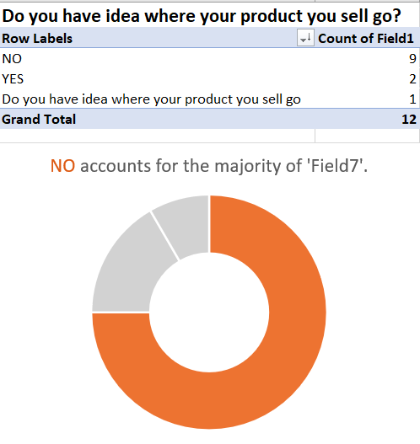

**For the following questions:**

-Name:

-Where are you from?

-What kind of products do farmers in your country produce?

-Satisfaction with current methods of selling agricultural products?

-Give us your thoughts on current system for exporting agricultural products?

-Do you have idea where your product you sell go?

-Give you rating of overall efficiency and effectiveness of current system for selling agricultural products?

-How easy is it for you to sell your product and what wastage do you face?

-What is the main challenge you face when selling your product at a fair price?

Got the following responses:

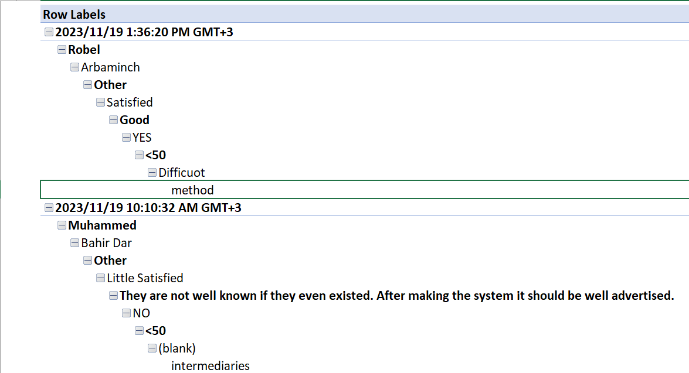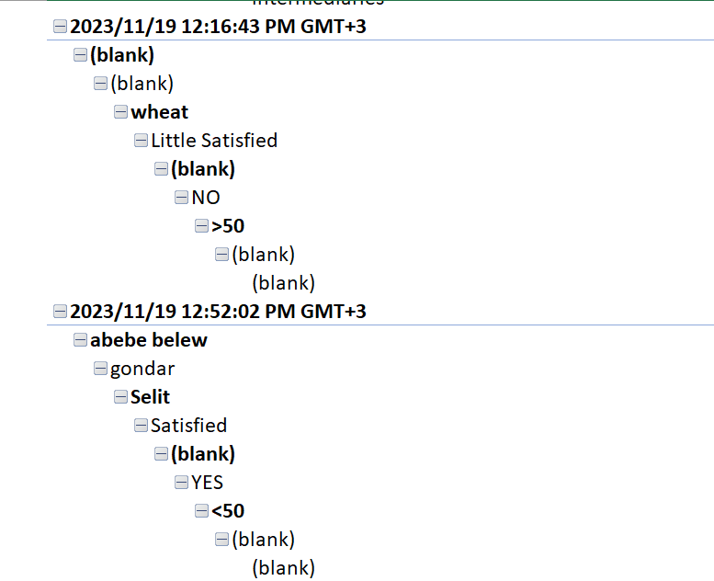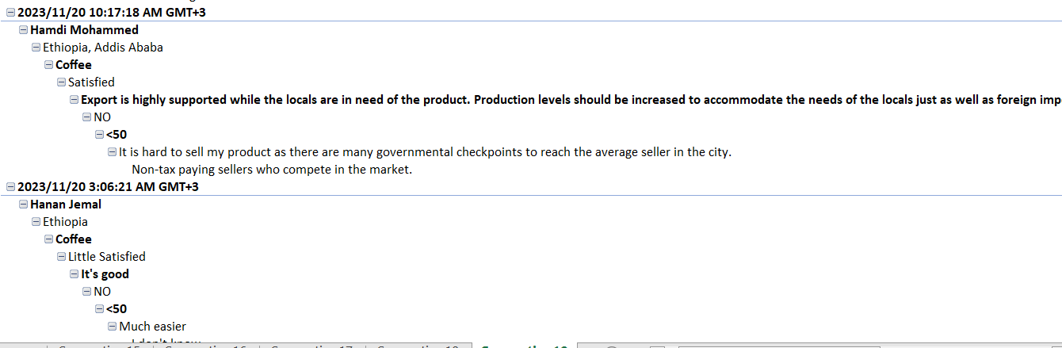



### 2.1.3. Requirement definition

(Read system books for the details)

#### 2.1.3.1. Functional requirements

(For example, the system will maintain a database about employee records, generate weekly

report, etc.)

#### 2.1.3.2. Non-functional requirements

(For example, security (the system is accessed through a password with encryption), availability.

(the system is designed on the web to accessible in 24 hours), learnability (uses graphical

interface for easy use, and learnability within a specified training time etc.), scalability (supports

n number of customers/users /clients concurrently with x amount of data per a given period etc.)